In this study, daily data on the closing values of the S&P 500 Index from 03-01-2022 to 03-08-2023 (398 observations) have been used. The return on the index has been calculated from these values. The days on which the index has gone up as compared to the previous day, have been marked as “Up”. The days on which the index has gone down as compared to the previous day, have been marked as “Down”. In another column we note down the return on the index that occurred one day previous to the current date (the return being calculated by comparing the closing value of the 1 day previous date with the closing value that occurred one day prior to the 1 day previous date). So, for the days marked as “Up”, we get a series of 1-day previous returns and for the days marked by “Down” we get a series of 1-day previous returns. Similarly, in another column we note down the return on the index that occurred 3-day previous to the current date (the return being calculated by comparing the closing value of the 3 day previous date with the closing value that occurred one day prior to the 3 day previous date). The goal of the exercise is to see if the descriptive statistics (median, sample s.d., skewness and kurtosis) of the 1-day previous return differ between the days on which the market was “Up” and the days when the market was “Down”; and to see if the descriptive statistics of the 3-day previous return differ between the days on which the market was “Up” and the days when the market was “Down”. Also, the goal is to see if the descriptive statistics for the ‘Up’ and ‘Down’ series differ when the outliers are removed.

The box plot of the 1-day previous return for the days when the market was “Up” and the days when the market was “Down” has been given below.

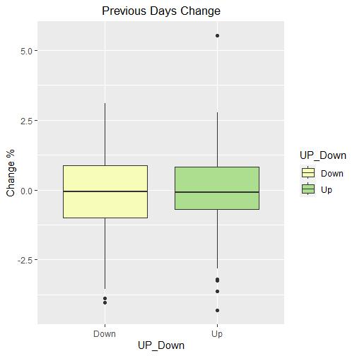

From the boxplot we find that there are 2 outliers for the series corresponding to “Down” and 5 outliers for the series corresponding to “Up”.

The histogram of the 1-day previous return (including these outliers) for the days when the market was “Up” and the days when the market was “Down” has been given below.

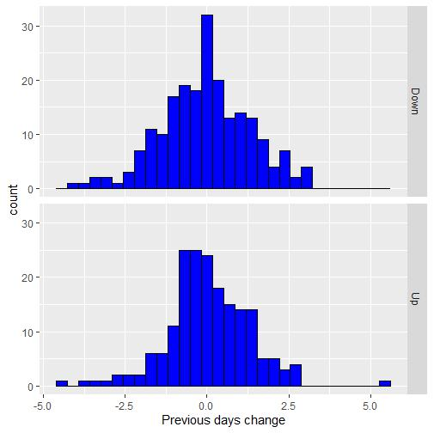

The descriptive statistics for the 1-day previous return (with outliers) has been shown in the following table.

|  |  |  |
| --- | --- | --- |
| Measure | Down | Up |
| Median | -0.0502% | -0.0896% |
| Sample s.d. | 1.3678% | 1.2748% |
| Skewness | -0.1121 | 0.0735 |
| Kurtosis | 3.0878 | 5.0670 |

The descriptive statistics for the 1-day previous return (without outliers) has been shown in the following table.

|  |  |  |
| --- | --- | --- |
| Measure | Down | Up |
| Median | -0.0334% | -0.0705% |
| Sample s.d. | 1.3189% | 1.0958% |
| Skewness | 0.0413 | 0.1274 |
| Kurtosis | 2.8420 | 2.9641 |

The effect of removal of outliers is mainly seen in the change in the value of the kurtosis.

The box plot of the 3-day previous return for the days when the market was “Up” and the days when the market was “Down” has been given below.

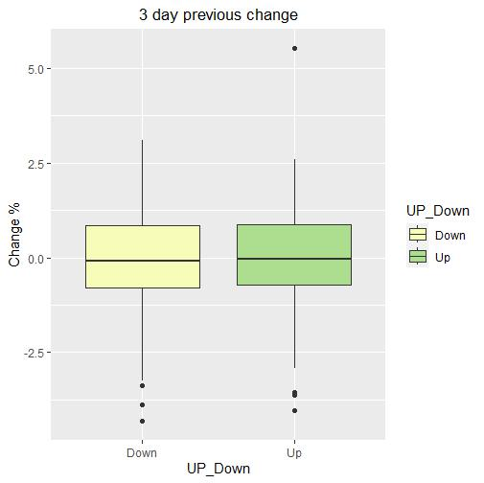

From the boxplot we find that there are 3 outliers for the series corresponding to “Down” and 4 outliers for the series corresponding to “Up”.

The histogram of the 3-day previous return (including these outliers) for the days when the market was “Up” and the days when the market was “Down” has been given below.

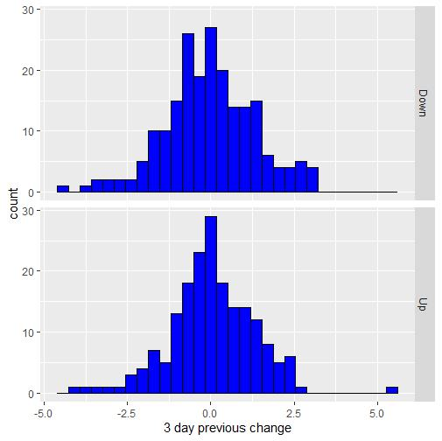

The descriptive statistics for the 3-day previous return (with outliers) has been shown in the following table.

|  |  |  |
| --- | --- | --- |
| Measure | Down | Up |
| Median | -0.0803% | -0.0394% |
| Sample s.d. | 1.3505% | 1.2992% |
| Skewness | -0.1260 | 0.0580 |
| Kurtosis | 3.3374 | 4.6225 |

The descriptive statistics for the 3-day previous return (without outliers) has been shown in the following table.

|  |  |  |
| --- | --- | --- |
| Measure | Down | Up |
| Median | -0.0629% | -0.0318% |
| Sample s.d. | 1.2770% | 1.1486% |
| Skewness | 0.1240 | -0.0116 |
| Kurtosis | 2.9456 | 2.8036 |

The effect of removal of outliers is mainly seen in the change in the value of the kurtosis.